**WEEK-2**

**Module 3 - PL/SQL Programming**

Exercise 3: Control Structures

//Creating the database

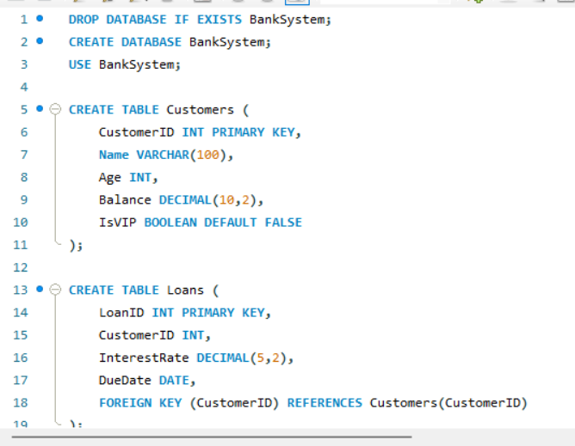

//Insertion of elements

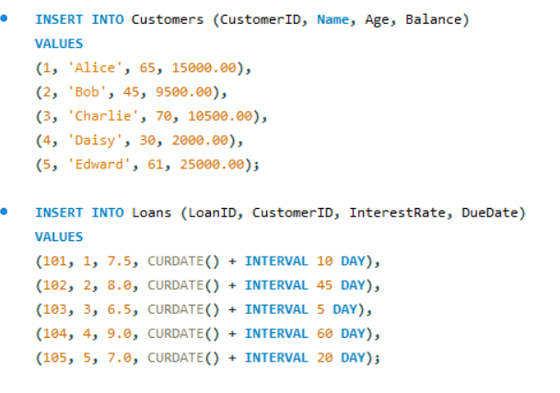

.

**Scenario 1:** The bank needs to process monthly interest for all savings accounts.

**Question:** Write a stored procedure **ProcessMonthlyInterest** that calculates and updates the balance of all savings accounts by applying an interest rate of 1% to the current balance.

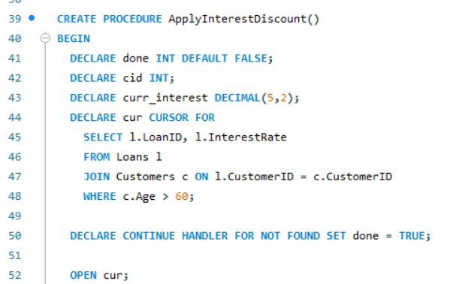

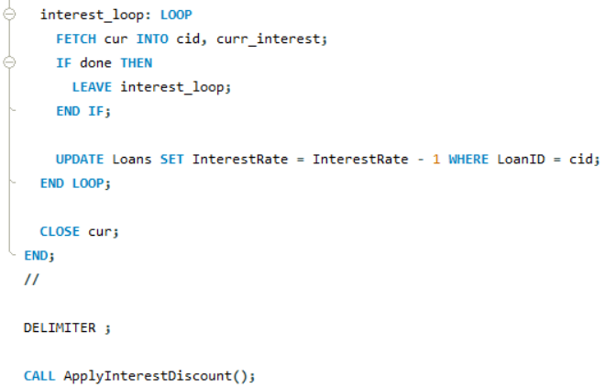

**OUTPUT**

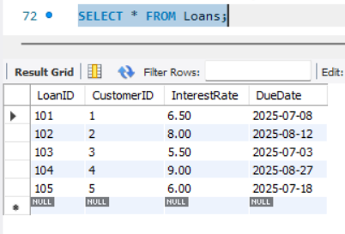

**Scenario 2:** The bank wants to implement a bonus scheme for employees based on their performance.  
**Question:** Write a stored procedure **UpdateEmployeeBonus** that updates the salary of employees in a given department by adding a bonus percentage passed as a parameter.

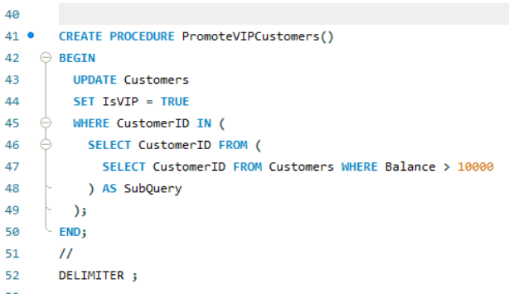   
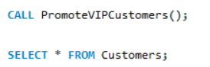

**OUTPUT**

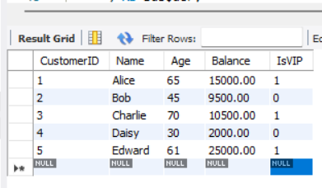

**Scenario 3:** The bank wants to send reminders to customers whose loans are due within the next 30 days.  
**Question:** Write a PL/SQL block that fetches all loans due in the next 30 days and prints a reminder message for each customer.

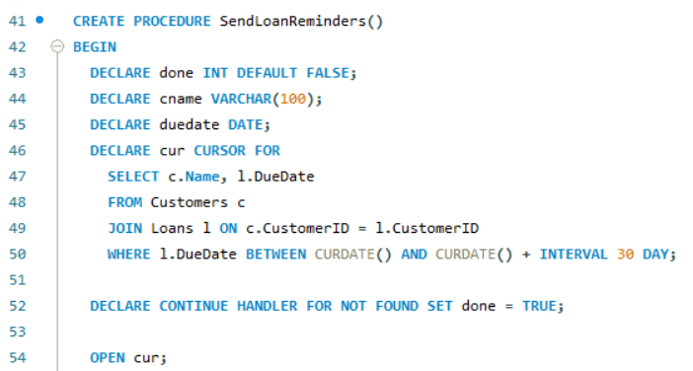

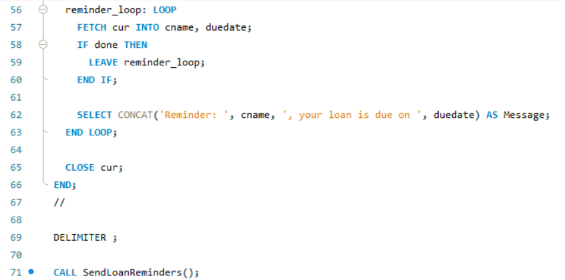

**OUTPUT**

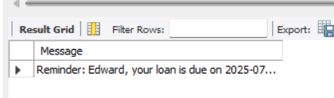

**EXERCISE 3: Stored Procedures**

//CREATING THE DATABASE

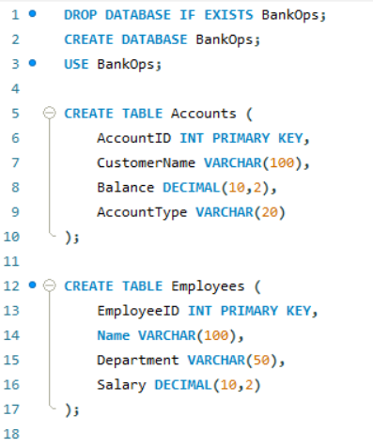

//INSERTING THE DATA

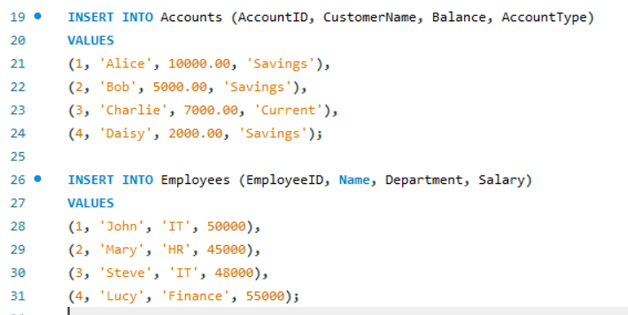

**Scenario 1:** The bank needs to process monthly interest for all savings accounts. **Question:** Write a stored procedure **ProcessMonthlyInterest** that calculates and updates the balance of all savings accounts by applying an interest rate of 1% to the current balance.

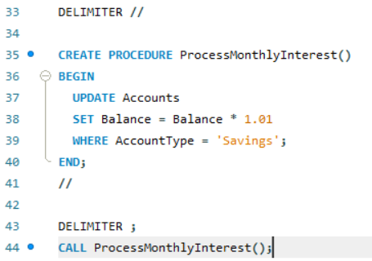

**OUTPUT**

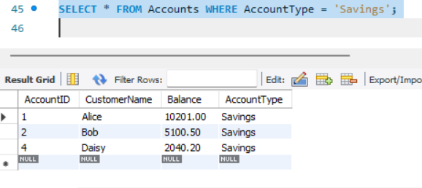

**Scenario 2:** The bank wants to implement a bonus scheme for employees based on their performance.

**Question:** Write a stored procedure **UpdateEmployeeBonus** that updates the salary of employees in a given department by adding a bonus percentage passed as a parameter.

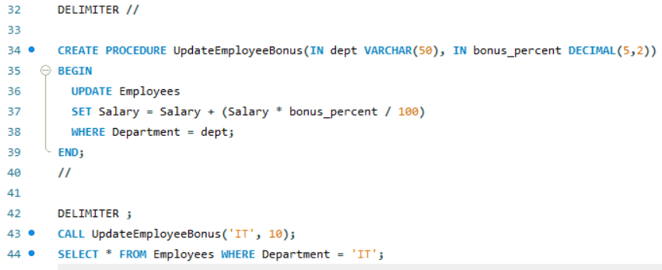

**OUTPUT**

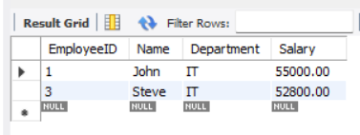

**Scenario 3:** Customers should be able to transfer funds between their accounts.  
**Question:** Write a stored procedure **TransferFunds** that transfers a specified amount from one account to another, checking that the source account has sufficient balance before making the transfer.

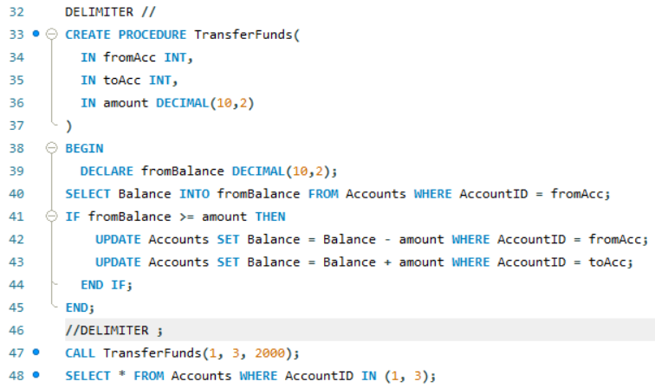

**OUTPUT**

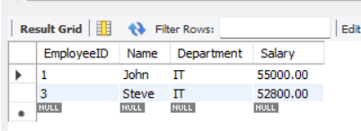

**JUnit Testing Exercises**

**Exercise 1: Setting Up JUnit**

Scenario:

You need to set up JUnit in your Java project to start writing unit tests.

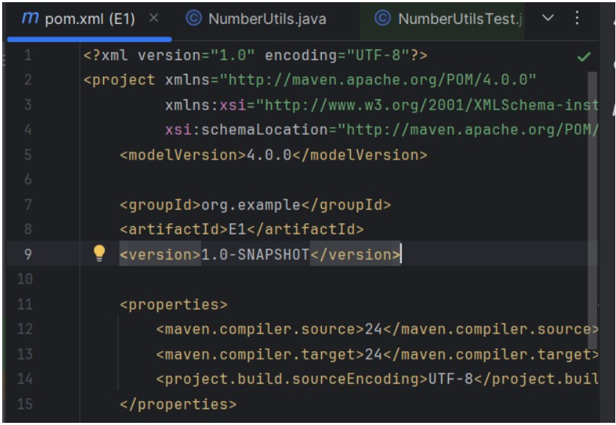

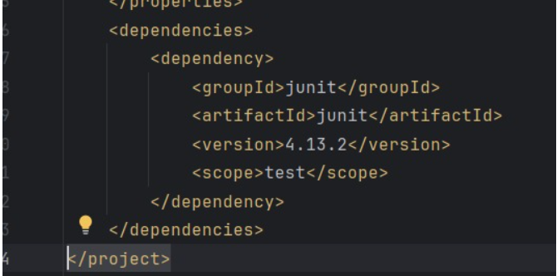

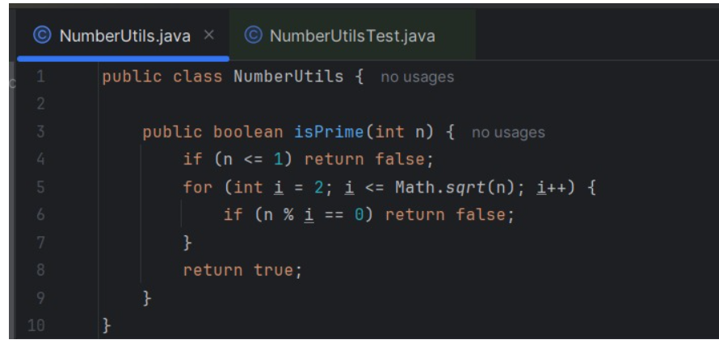

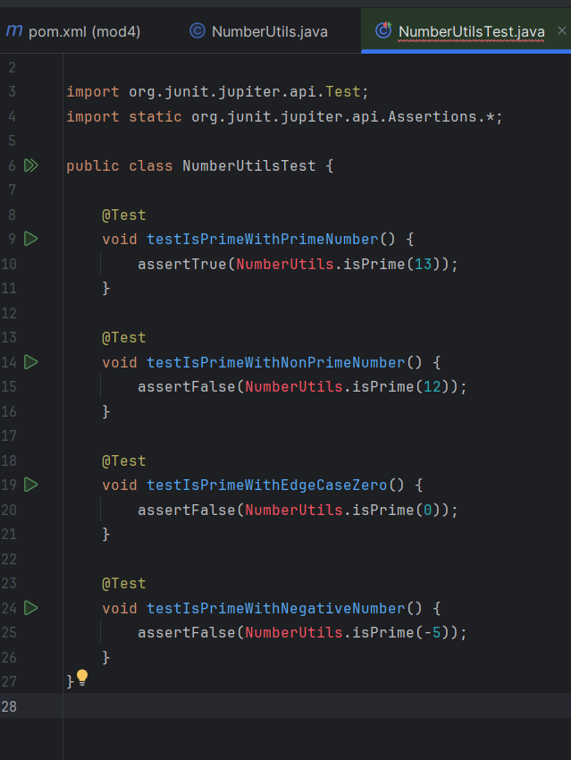

OUTPUT

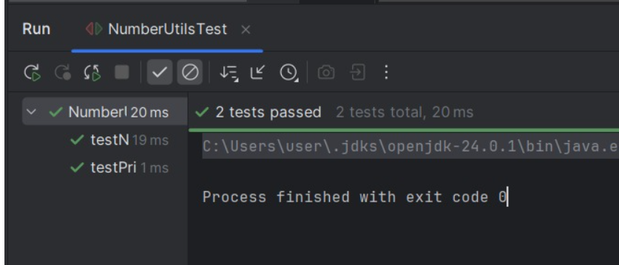

Exercise 2: Writing Basic JUnit Tests

Scenario:

You need to write basic JUnit tests for a simple Java classlts

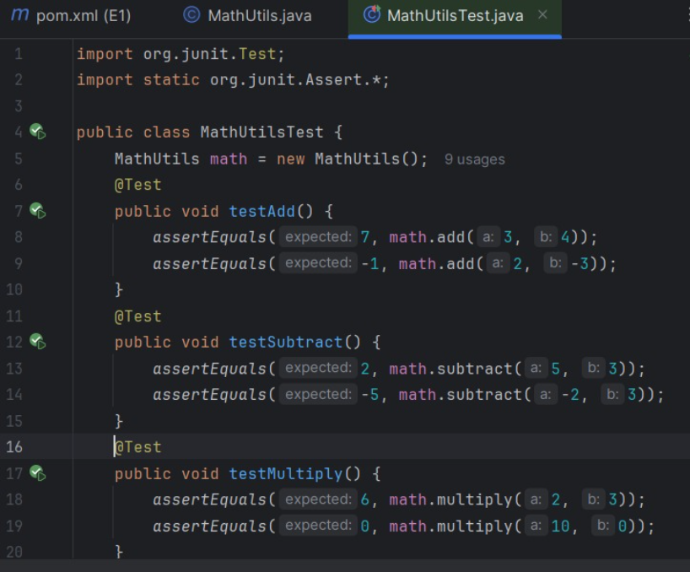

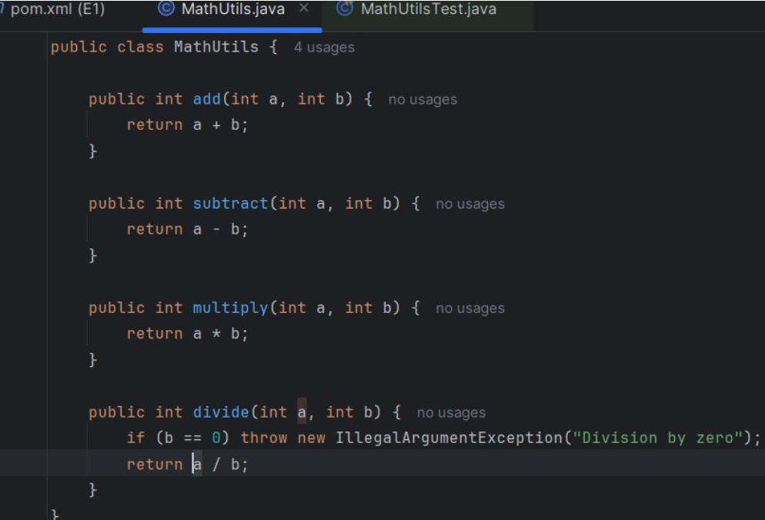

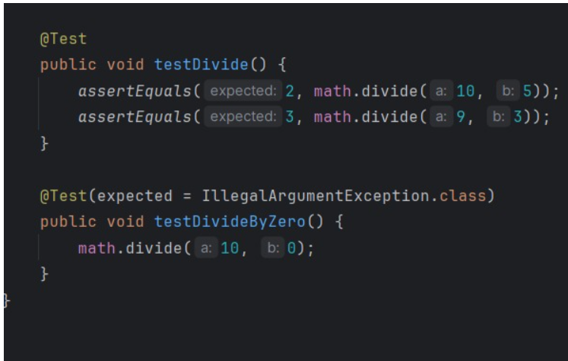

**OUTPUT**

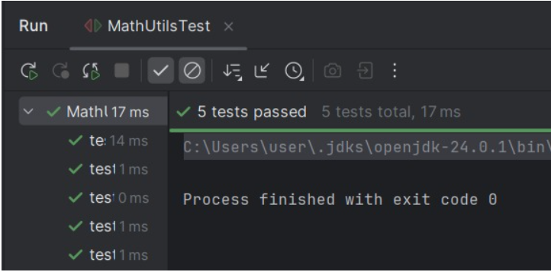

Exercise 3: Assertions in JUnit

Scenario:

You need to use different assertions in JUnit to validate your test results.

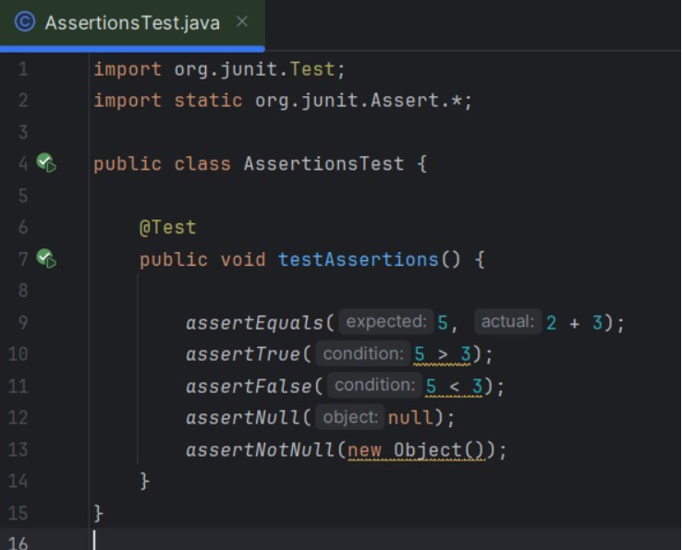

**OUTPUT**

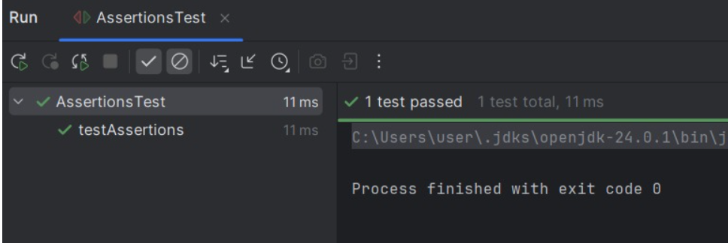

Exercise 4: Arrange-Act-Assert (AAA) Pattern, Test Fixtures, Setup and

Teardown Methods in JUnit

Scenario:

You need to organize your tests using the Arrange-Act-Assert (AAA) pattern and use setup

and teardown methods

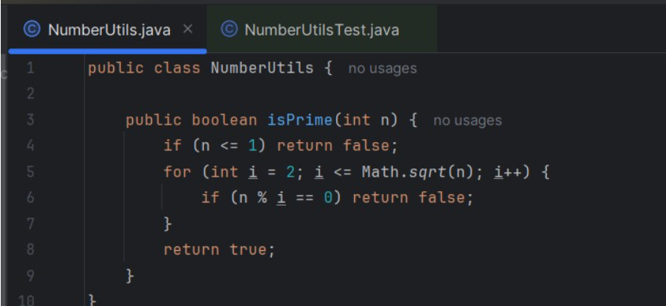

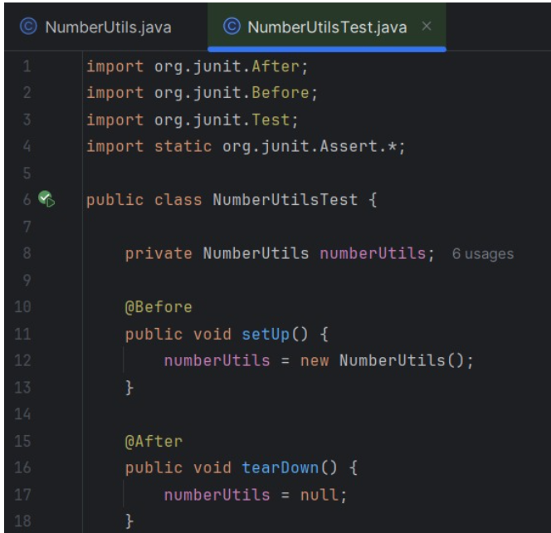

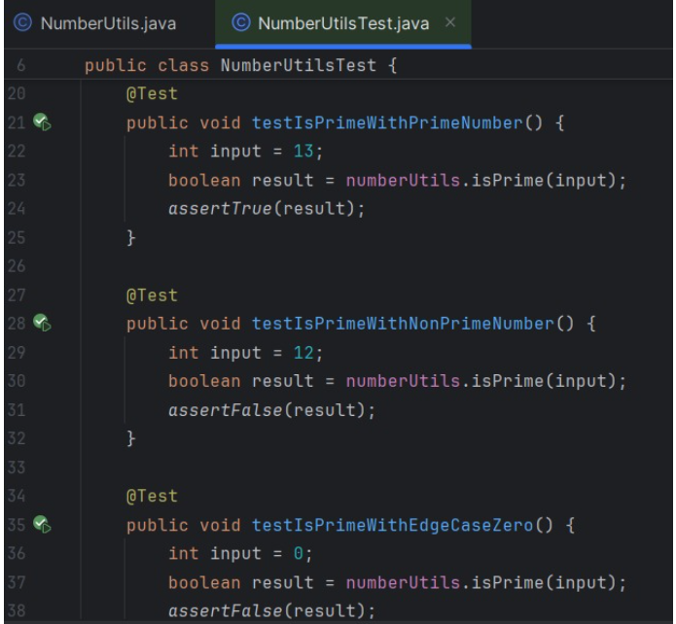

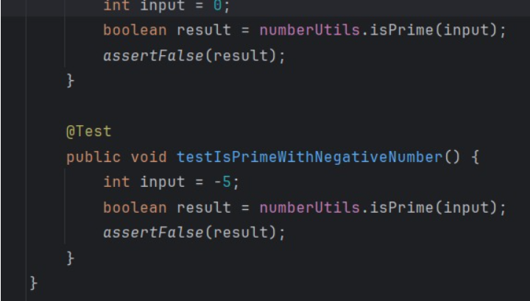

**OUTPUT**

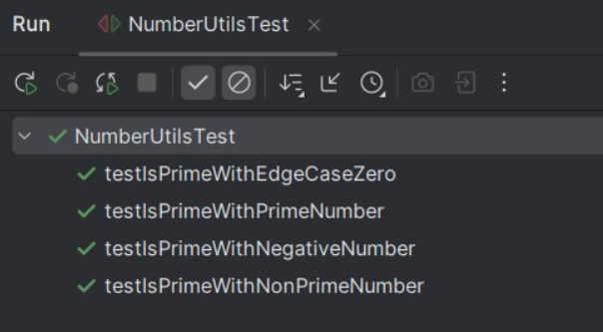

**TDD using JUnit5 and Mockito**

**Exercise 1: Mocking and Stubbing**

Scenario:

You need to test a service that depends on an external API. Use Mockito to mock the

external API and stub its methods.

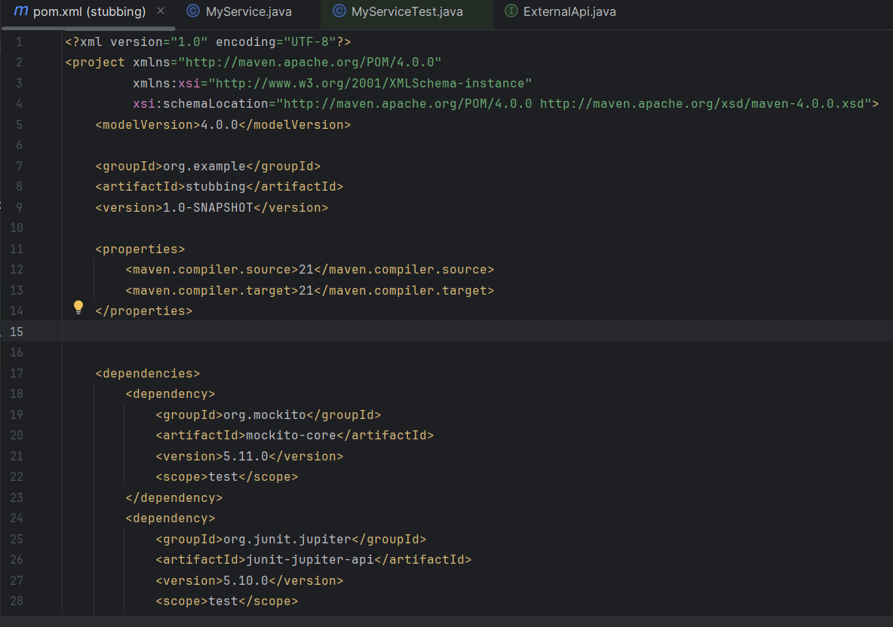

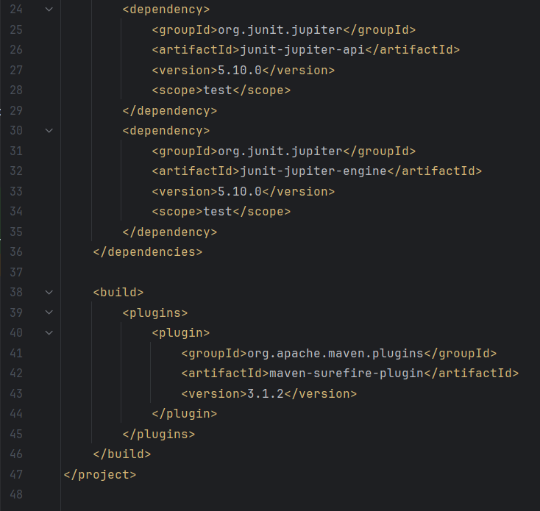

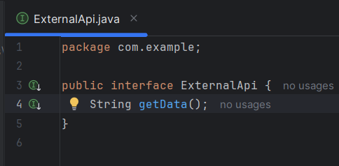

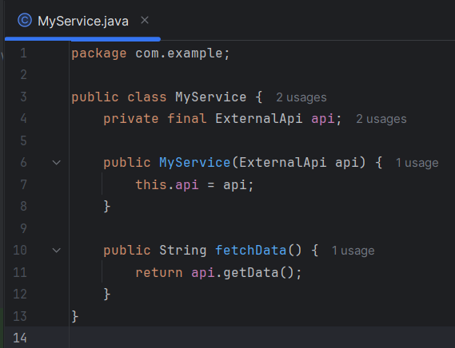

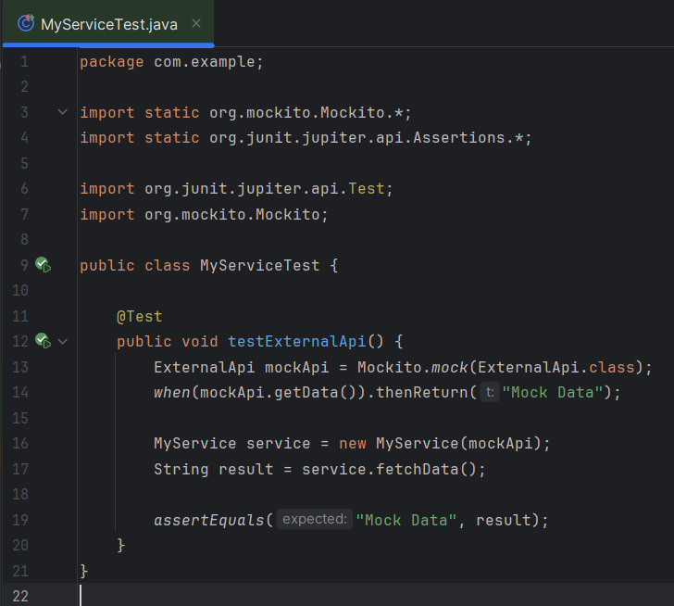

**OUTPUT  
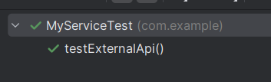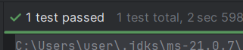**

**Exercise 2: Verifying Interactions**

Scenario:

You need to ensure that a method is called with specific arguments.

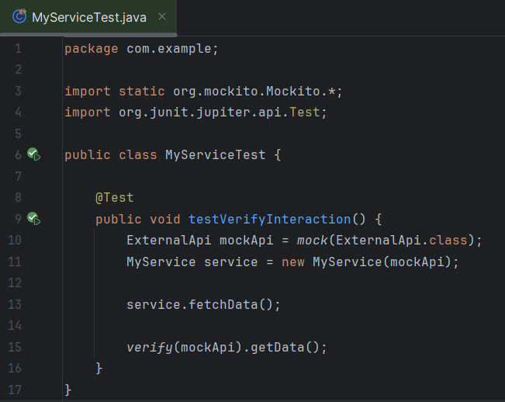

**OUTPUT**

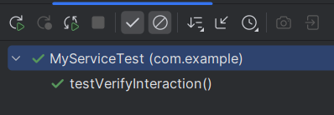

**Logging using SLF4J**

**Exercise 1: Logging Error Messages and Warning Levels**

Task: Write a Java application that demonstrates logging error messages and warning levels

using SLF4J

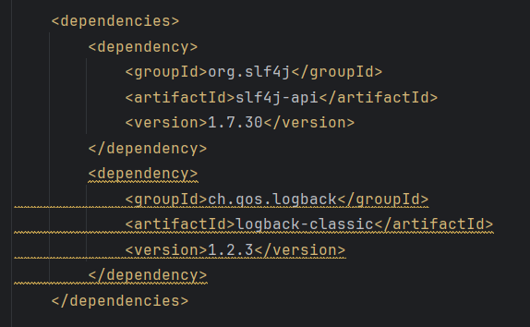

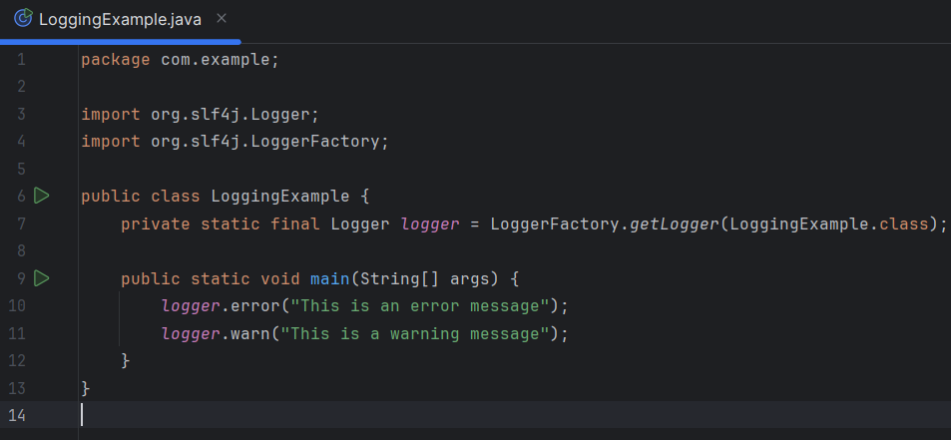

**OUTPUT**

